
CLEAR REFLECTION

MIRROR CATEGORY
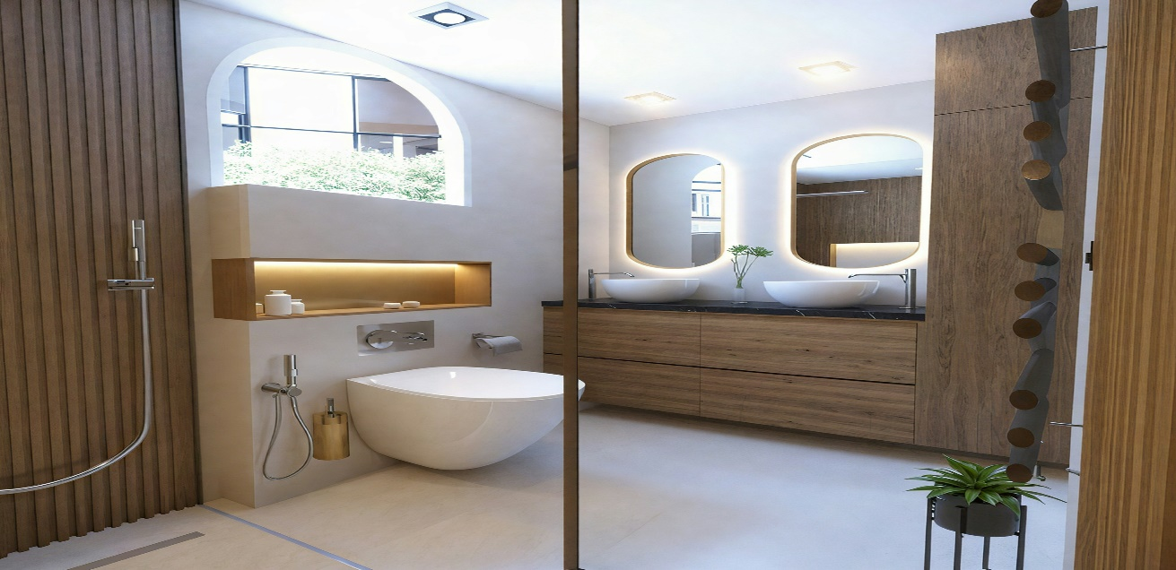
“BATHROOM MIRROR”
Bathroom mirrors are an essential feature that combines practicality with modern design, enhancing both the functionality and appearance of the space. A well-designed bathroom mirror provides clear visibility for daily tasks such as grooming, shaving, and skincare, while also contributing to a clean and stylish look. Whether it is a wall-mounted mirror, a cabinet mirror, or a mirror with built-in lighting, it helps maximize light and makes the bathroom feel more spacious and organized. Bathroom mirrors are available in a variety of shapes, sizes, and finishes, allowing them to suit contemporary, minimal, or luxurious interiors. High-quality bathroom mirrors are crafted with moisture-resistant, distortion-free glass to ensure durability and long-lasting clarity in humid environments. Overall, a bathroom mirror is not just a functional necessity but a refined design element that adds brightness, comfort, and elegance to the bathroom space. They also enhance the overall hygiene and organization of the bathroom by providing smart storage options and clear reflections. A well-chosen bathroom mirror adds a fresh, relaxing feel, turning the bathroom into a more comfortable and visually appealing space.

